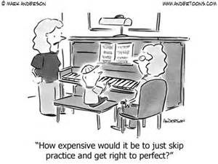

# Students as Teachers Project 2016

## Assignment #1 “The Agreement”

**1. The “TEACHER” (that’s you) will find a suitable student. It’s best to choose the parent or relative that has never played this instrument before. If you can’t find a relative, try a neighbor, friend of the family, former teacher or even a principal! By picking someone who has never played the instrument before, you will get a better idea of how good a teacher you really are. You can tell them there will be six lessons and the project will last approximately 5 weeks.**

**2. The “STUDENT” (that’s the parent/relative/friend) must be 18 years of age or older. They will agree to meet weekly with their teacher for a lesson and 15 minutes of supervised practice. Each lesson will cover one or two points and require fine teaching and demonstrating to complete. At the end of every lesson, the teacher and student will sign the lesson sheet to verify its completion. The concert will be at the very end of the project!**

### Signatures of Agreement

**_________________________ _______________________________**

**teacher student**

**(student in 6th grade band) (the adult involved. . . )**

**relationship to the teacher (mother, father, friend of the family, grandma, teacher, etc.) ______________________________________________**

**This sheet is due on Monday, February 8.**

**\*\*\*\*\*\*\*\*\*\*\*\*\*\*\*\*\*\*\*\*\*\*\*\*\*\*\*\*\*\*\*\*\*\*\*\*\*\*\*\*\*\*\*\*\*\*\*\*\*\*\*\*\*\*\*\*\*\*\*\*\*\*\*\*\*\***

**All participants in the “Students as Teachers” are invited to be a part of the 6th grade recital scheduled for March 7th at 7:00 p.m. in the high school auditorium. The adult band (with lots of help and guidance) will display the work of their teachers that evening!**

**NOTE: This is a required project for all members of the 6th grade band. If there is no adult available amongst friends or family, please let me know and I will assist your child in finding an adult here in the middle school who will act as a music student for your child!!**